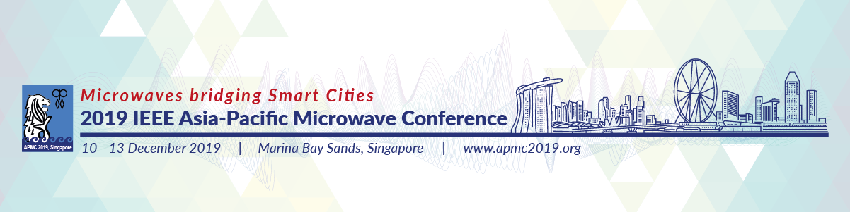

Call for Proposals – Special Sessions
(Deadline: 10 June, 2019)

The APMC 2019 organizing committee cordially invites proposals for Special Sessions in this conference. Special Session organizers are required to complete the table below with the proposed topic and scope, and return the form to us (via email: elechenx@nus.edu.sg) by 10 June, 2019. Please list down the suggested speakers and/or the tentative titles of their papers if known at this time. Here are some notes for your attention:
- A special session is expected to have at least 5 papers. If more papers are received for a special session, it will be split into part A and part B.
- Please note that all proposals will be evaluated by the committee considering various factors. All papers will be reviewed as regular submissions by external reviewers besides session organizers. One-page abstract is allowed for the special session but the one-page abstract will not be included in IEEE Xplore.
- All organizers/speakers are encouraged to invite speakers from diversified regions/countries.
- All organizers and speakers are required to register for the conference with corresponding registration fees.
- We would like to seek your understanding that the special sessions may be cancelled or combined with other sessions of similar topics should there be insufficient number of speakers.

Organizers’ information (for each organizer, please provide Name, Affiliation, Email)
Title of Session
Abstract of Session (less than 200 words)
List of speakers and/or titles of their papers (if known)

